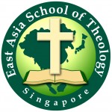
EAST ASIA SCHOOL OF THEOLOGY
Developing Christlike Leaders for the Great Commission
118 Joo Chiat Road, #04-01, Singapore 427407
Tel: (65) 6291 9744
www.east.edu.sg

East Asia School of Theology (EAST) was founded in 1992. EAST is committed to provide men and women with a Christ-centered theological education and to equip them for ministries in Asia and beyond.

The primary purpose is to glorify God by equipping leaders for the Great Commission in Asia. Today, about 90 percent of EAST graduates are actively serving in over 25 countries of cross-cultural mission fields in Asia, Africa, America, Australia, and Europe. Most of them are serving to reach Unreached People Groups (ethnic people group that has no known local church, no and less than 2% of the population are Christians.)

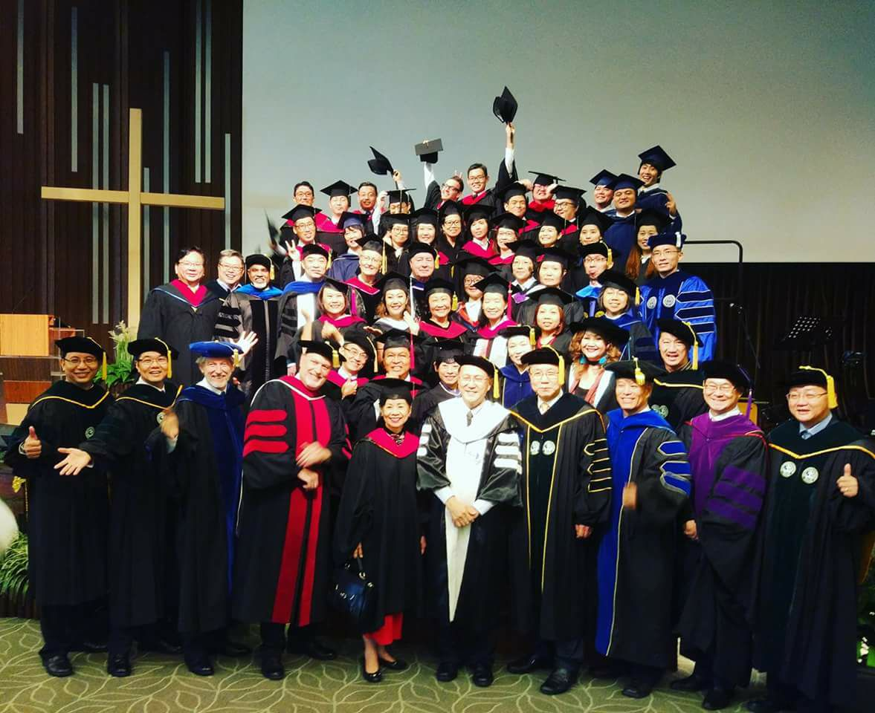

Students come mostly from Asia, such as Singapore, China, Hong Kong, India, Indonesia, Malaysia, Mongolia, Myanmar, Cambodia, Philippines, Vietnam, Japan, Korea, and the USA.

EAST provides open doors to study and help students where their natural environments are not conducive to such unique training that EAST can offer. EAST gives them great opportunities to learn and to be life-long laborers for God’s Kingdom work.
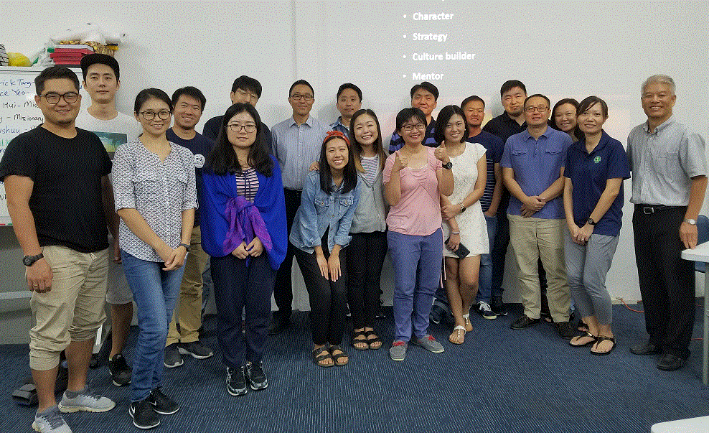
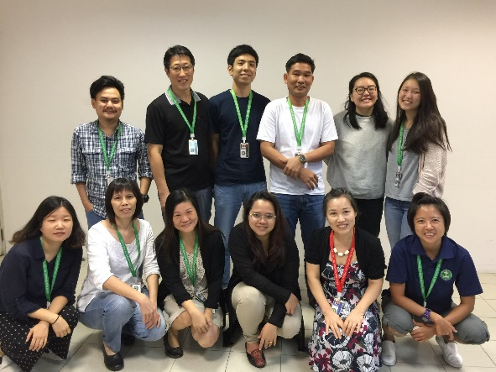

The vision of EAST is to
"help transform East Asia through mobilizing lifetime laborers and sending cross-cultural missionaries to the world by being people who truly follow Jesus, boldly proclaiming Jesus, making disciples, and multiplying Christ-centered leaders and spiritual movements."
EAST seeks to develop leaders who are:
• Committed to growing in Christ-likeness,
• Passionate spiritual multipliers,
• Learning and living out God’s Word, and
• Communicating God’s truth effectively.

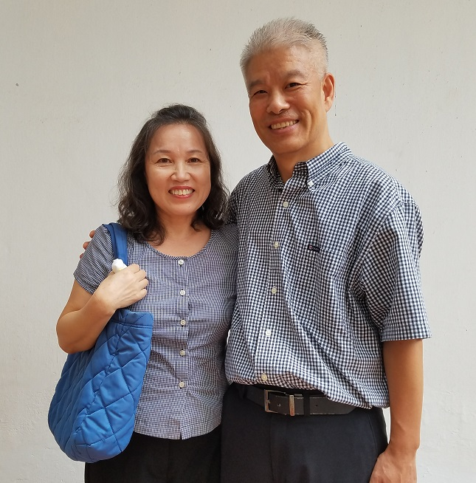

Raymond & Justine Song
67A Carlisle Rd., Singapore, 219638
(Raymond cell) 1-847-778-8821 prsong@gmail.com
(Justine cell) 1-847-641-0542 hanhjustine@gmail.com

